**Database Application Programming**

**Project Status and Design Report**

|  |  |
| --- | --- |
| **Topic:** | *Topic 2: PHP Control Constructs, Operators, and Variables* |
| **Date:** | *09/30/20* |
| **Revision:** | *2.0* |
|  | |  |  |  | | --- | --- | --- | | **Task** | **Hours Worked** | **Hours Remaining** | | *Updated Registration form with required data fields* | *1* | *0* | | *Updated Welcome Page* | *1* | *0* | | *Created login page with connection to Database with required data fields* | *1* | *0* | | *Adding CSS to pages* | *2.5* | *0* | | *Finish documentation* | *2* | *0* | |  |  |  | |  |  |  | |  |  |  | |  |  |  | |  |  |  | |  |  |  | |  |  |  | |  |  |  | |
| **GIT URL:** | *https://github.com/MrDuise/Blog-Project.git* |
| **Hosting URL:** | *N/A* |

**Supporting Design Documentation**

**Install Instructions:**

Installed MAMP, setup a database called ‘registration’ with a table called ‘users’ to store the registration information. Table includes the columns ID, USER_NAME, LAST_NAME, Email, and Password. ID is auto incremented. In order to run this code, you need MAMP installed, the server ports set to the MAMP default, and the web server being used to be set to Apache. The files need to be in the document root C:\MAMP\htdocs

**General Technical Approach:**

For version 2.0 of my project, which is a part of the milestone 2 requirement, I expanded on a lot on both the CSS and functionality of the pages. Each page now has a navbar at the top, allowing access to each of the main pages. The pages are the welcome page, the registration page, and the login in page. This expands the usability of the blog in so that the user does not have to use the back button to go back to an earlier page. The registration complete page also has a navbar at the top allowing the user to either register a new user or login to their account.

**Key Technical Design Decisions:**

Version 2.0 does not allow blank entry forms in either the registration or login pages. All data forms must be entered in order to either create a new user or login. It does allow an unlimited number of attempts to login in though as well as multiple users to be inserted with the same username and password. This will be changed in the next revision.

**ER Diagram:**

*N/A*

**DDL Scripts:**

*N/A*

**Sitemap Diagram:**

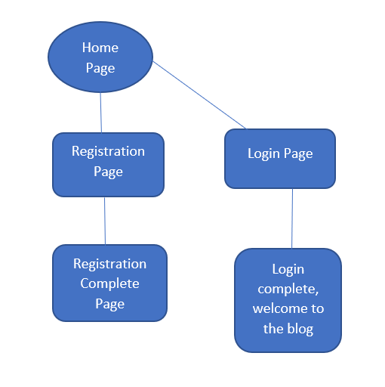

**User Interface Diagrams:**

Registration complete page

Welcome page

Registration Page

Login page

**Other Documentation:**

N/A

**Database Application Programming**

**Project Status and Design Report**

|  |  |
| --- | --- |
| **Topic:** | *Topic 1: Introduction to PHP and MySQL* |
| **Date:** | *09/18/20* |
| **Revision:** | *1.0* |
|  | |  |  |  | | --- | --- | --- | | **Task** | **Hours Worked** | **Hours Remaining** | | *Created HTML Registration Form* | *1* | *0* | | *Created Welcome Page* | *1* | *0* | | *Created Data Capture page with connection to Database* | *1* | *0* | | *Adding CSS to pages* | *2.5* | *0* | |  |  |  | |  |  |  | |  |  |  | |  |  |  | |  |  |  | |  |  |  | |  |  |  | |  |  |  | |  |  |  | |
| **GIT URL:** | *https://github.com/MrDuise/Blog-Project.git* |
| **Hosting URL:** | *N/A* |

**Supporting Design Documentation**

**Install Instructions:**

Installed MAMP, setup a database called registration with a table called users to store the registration information. Table includes the columns ID, USER_NAME, LAST_NAME, Email, and Password. ID is auto incremented. In order to run this code you need MAMP installed, the server ports set to the MAMP default, and the web server being used to be set to Apache. The files need to be in the document root C:\MAMP\htdocs

**General Technical Approach:**

For version 1.0 of my project, which is a part of the milestone 1 requirement, my project is very simple. I have a welcome page, registration page, and some text that gets displayed after the data has been entered into the form. Text for each page is centered into the center of the screen as I felt it looked better than being off to the side. It focuses the user’s attention. The welcome page displays text welcoming the user to the page with a button below that says register. Clicking on this button opens the registration page, which has a php form action attached to it allowing the data the user enters to be inserted into the database. This page also displays a message when the user has completed registration.

**Key Technical Design Decisions:**

This is a basic attempt. Code does not include any security or error checking. Database entries will be made even if no data in entered into the form.

**ER Diagram:**

*N/A*

**DDL Scripts:**

*N/A*

**Sitemap Diagram:**

Login page and Blog home page have not been started yet. This diagram was designed after the coding process had already begun. Currently the only pages are the welcome page, register page, and registration complete page.

**User Interface Diagrams:**

This is a first attempt, basic page. Nothings was planned out ahead of time. I just wanted to make the registration page. Cover/welcome page was added after register page was already complete.

**Other Documentation:**

N/A